Google’s HQ, otherwise known as Googleplex, is situated in Mountain view, California in Silicon Valley. Throughout the corridors between the four buildings, there are all sorts of Google memorabilia on display. They even employ guides who specialize in explaining Google’s history to people. There are lava lamps everywhere, as well as free coke and candy all over the place. They’ve also got huge multicolored exercise balls everywhere.
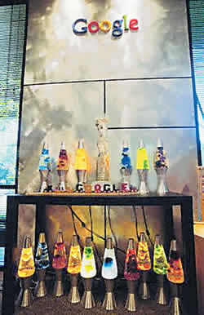
People’s workspaces are full of individuality, and the atmosphere is relaxed. There are couches everywhere. People can have a lie down when they need to and take a break.
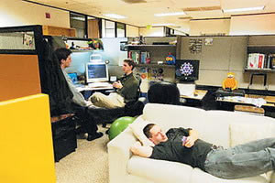
Google’s staff loves sports. The big guns often have meetings at the pool table or in the corridors.
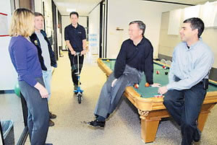
The casual atmosphere in Google HQ can be demonstrated by the fact that staff can bring their pets to work, and the pets are allowed to wander around the office.
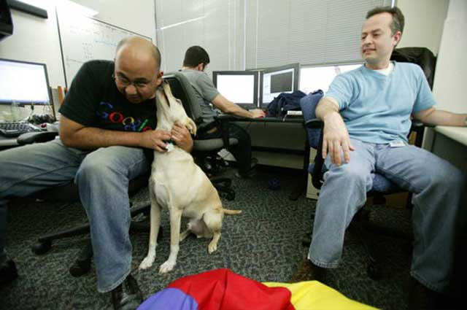
Heaps of people have pets at Google HQ.
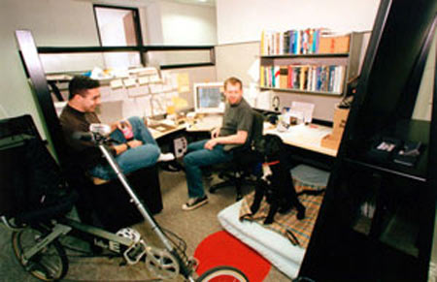

There’s a rule within Google: that there must be food within 100 feet of every employee.
There was once an engineer who felt a bit ripped off about that rule because his nearest food counter was 120 feet away, so he asked for the error to be corrected, tongue in cheek. The relevant department replied: “There’s a restaurant right above your desk, and you are definitely less than 100 feet from that one.”
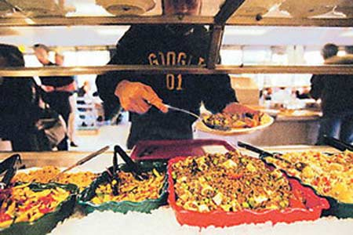
This looks more like a toyshop than a workspace!
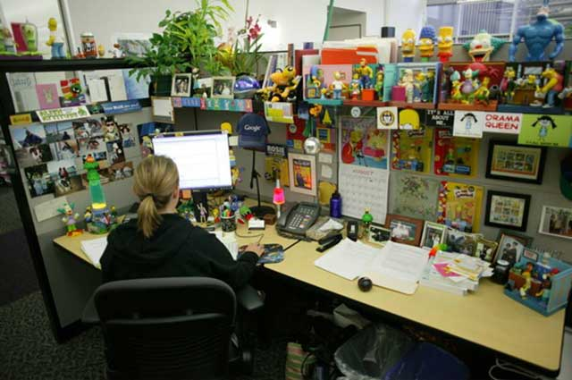
Rumor has it, a dude who had just joined Google had not been able to find a flat, so he lived at Google HQ for a month. He lived a lot better than Tom Hanks in The Terminal. Meals are provided, couches everywhere, there are showers in the bathrooms, a gym and a swimming machine. There are even pianos in music rooms you could use. Better than the facilities at home! The dude didn’t leave Google HQ for a month straight.
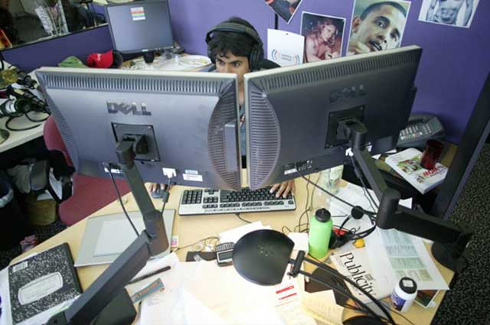
It’s all fun and games!
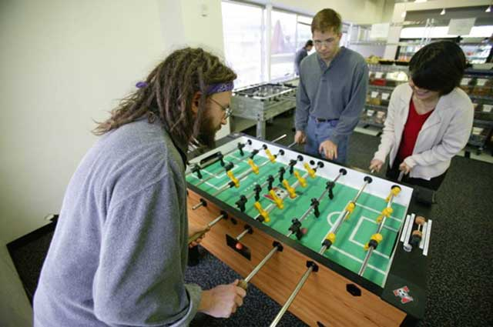

Whiteboards at Google HQ are filled with all sorts of great (or not) ideas in all sorts of different languages.
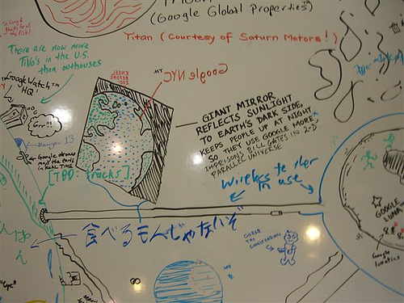
There’s free food all over the place, it almost look like a supermarket.
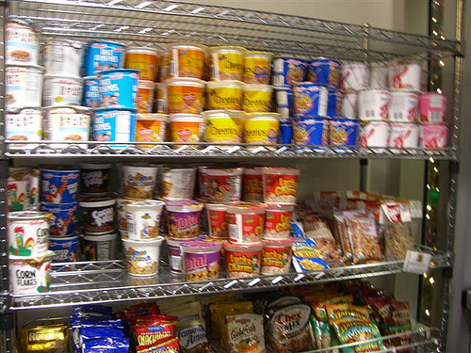
Hmmmmmmmm chocolate!
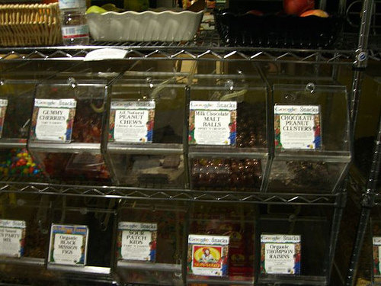
There’s also a free laundry room for use for the staff.
